**DAILY ONLINE ACTIVITIES SUMMARY**

|  |  |  |  |  |  |  |  |  |
| --- | --- | --- | --- | --- | --- | --- | --- | --- |
| **Date:** | **27/06/2020** | | | | | **Name:** | **Hanan Saleem Baji** | |
| **Sem & Sec** | **4th SEM 'A' Section** | | | | | **USN:** | **4AL18CS024** | |
| **Online Test Summary** | | | | | | | | |
| **Subject** | | Data Communication | | | | | | |
| **Max. Marks** | | 30 | | **Score** | | | 19 | |
| **Certification Course Summary** | | | | | | | | |
| **Course** | **1.Predictive Modeling and Analytics** | | | | | | | |
| **Certificate Provider** | | | **1. Great Learning Academy** | | **Duration** | | | **1. 3 hour** |
| **Coding Challenges** | | | | | | | | |
| **Problem Statement:** 1. Write a C program to print kth digit.  2. Write a C++ program to find sum of diagonals.  .  For example | | | | | | | | |
| **Status: completed** | | | | | | | | |
| **Uploaded the report in Github** | | | | | **Yes** | | | |
| **If yes Repository name** | | | | | 1. <https://github.com/saleemhananbaji/C-coding> | | | |
| **Uploaded the report in slack** | | | | | **Yes** | | | |

ONLINE TEST DETAILS: Online test was conducted on fifth module of **Data Communication**. Test contains 30 questions of 1 mark each. I have scored 19 Marks.

Snapshot:

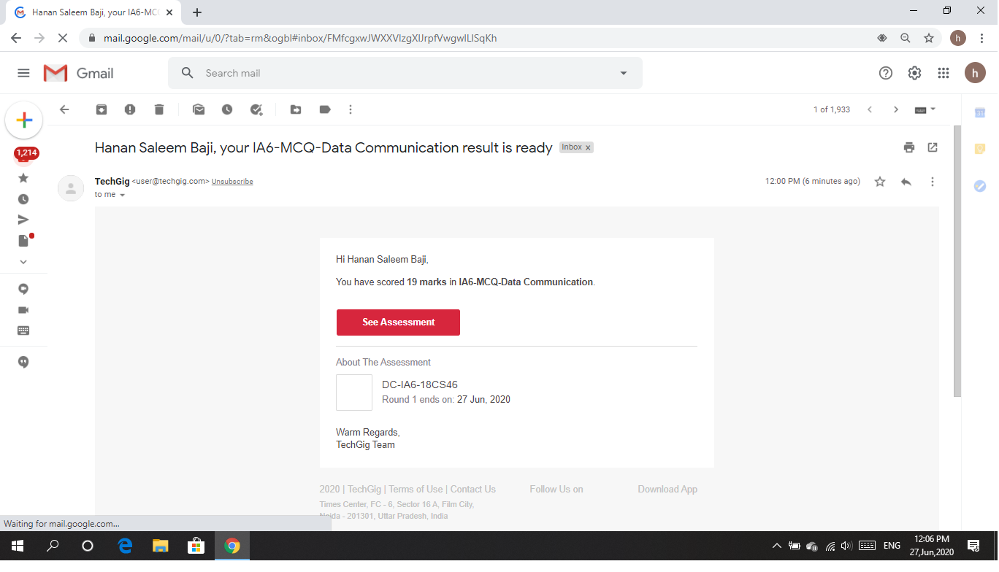

Certification Course Details: As the continuation of online course, I have completed Predictive modeling-classification techniques, Logistic regression-3 and logistic regression-hands on.

Snapshot:

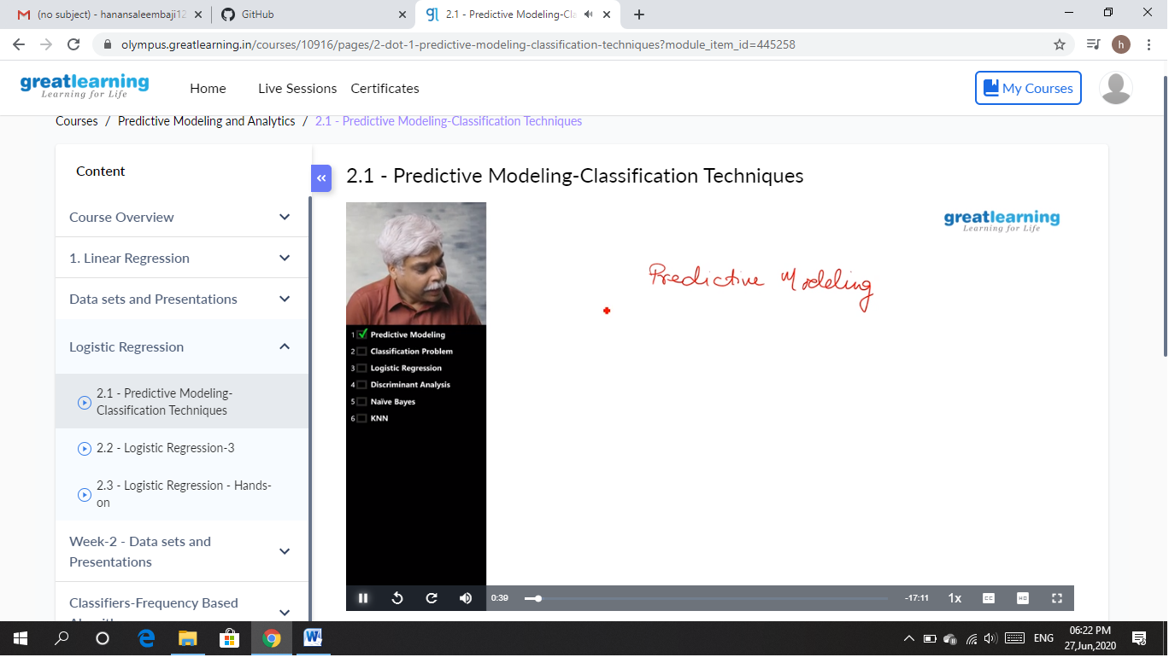

CODING CHALLENGES DETAILS: Problem statements

1. Write a C program to print kth digit.

Solution: Uploaded it in github

Snapshot:

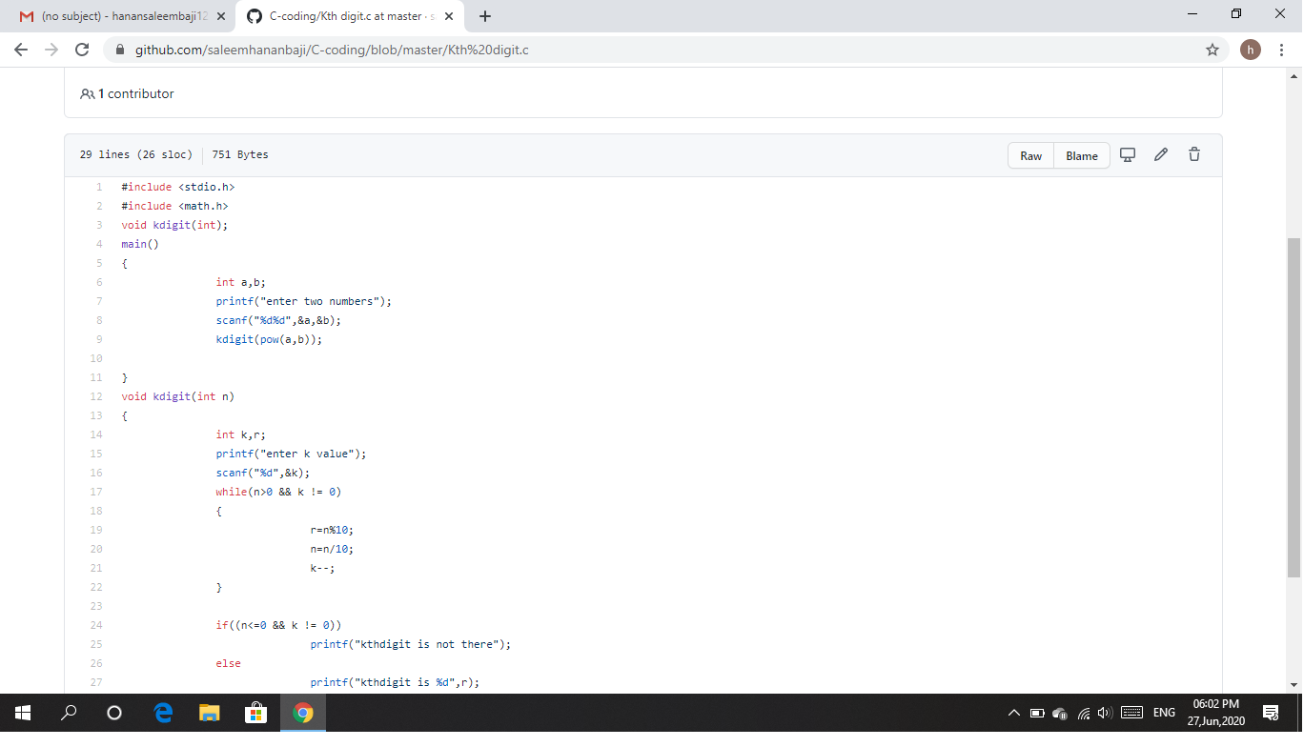

1. Write a C++ program to find sum of diagonals.

Solution: Uploaded it in github

Snapshot:

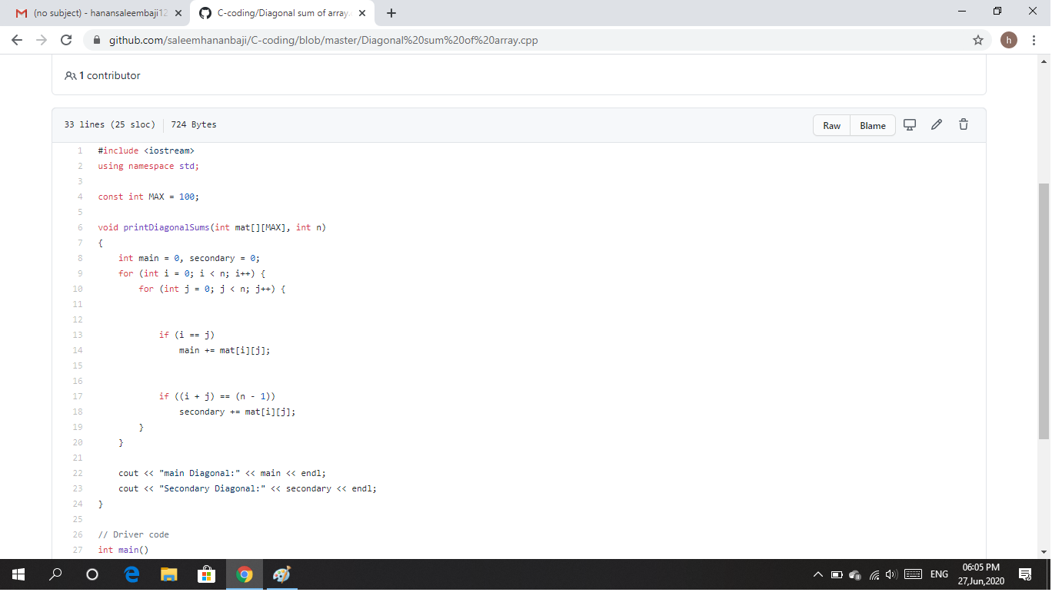

Webinar Details: Today I have attended the webinar on “Loops and conditions of C” by Assistant professor Ms.Megha hegde, CSE department, AIET. The session was very interesting. There was assessment conducted based on the webinar.

Snapshot:

